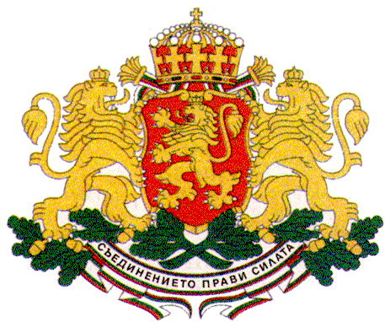 | PERMANENT MISSION OF THE REPUBLIC OF  BULGARIA  TO THE UNITED NATIONS
11 East 84th Street, New York, NY 10028, Tel: (212) 737 4790, Fax: (212) 472 9865, e-mail: bulgaria@un.int

World Youth Skills Day 2017
“Youth in Science, Technology, Engineering and Math (STEM) for achieving peace and positive social change for all”
New York, 14 July 2017, 9.00 am - 10.30 am, CR 8, UNHQs

H.E. Mr. Georgi Panayotov, Permanent Representative of Bulgaria to the United Nations
Opening Remarks

Excellencies,
Distinguished Guests,
Young people between the age of 10 and 24 form a quarter of the world’s population thus representing a major human resource for the prosperity of their societies and the global community in general.
Bulgaria believes that children and youth can be the key agents of positive social change and actively promotes their human rights and their meaningful participation in all spheres of the social and political life.
I would like to acknowledge the presence of H.E. Ms. Ofeliya Kaneva - President of the State Agency for Child Protection with the Council of Ministers of Bulgaria – who coordinates the implementation of the state policy on children’s rights in Bulgaria.
The realization of the human rights of children and youth and their empowerment through education and employment is crucial for achieving sustainable development and peaceful and inclusive societies as envisaged in the ambitious 2030 Agenda for Sustainable Development.
Lack of quality education and employment however, constitute major obstacles for young people to realize their full potential and play an active role in their societies.
Young people tend to be three times more likely than adults to be unemployed. Globally, one in six young people is without a job and not in education or training.
In the last couple of years the global youth unemployment rate has been decreasing which is encouraging to see but it is still way above the pre-crisis levels. More young women and men are in education but the difficulties as regards labour market transition remain.
So how can we solve these pressing issues?
Greater recognition and investment in non-formal education could be a viable solution. Social entrepreneurship is another useful tool to address those challenges in a sustainable way by empowering young people to create job opportunities themselves. Non-formal education and social entrepreneurship are crucial also for the inclusion of young persons with disabilities in the labour market which in the long run could contribute to reducing the rate of youth unemployment in general.

Women and girls face even greater challenges only due to their gender which fuels unemployment and perpetuates poverty. Progress has been made globally to close the gender gaps in education and labour market participation, but gender differences within education and employment persist. And when it comes to science, technology, engineering and mathematics (STEM) women continue to be extremely underrepresented despite the fact that more women graduate from university worldwide than men.
So the question is what can we do to get women involved in STEM?
And to me the answer is very simple - gender equality.
Efforts to ensure women’s and girls’ participation in STEM should form part of a wider strategy for gender equality in research and innovation that provides for equal access to education, equal employment opportunities, equal pay for equal work, eliminating horizontal and vertical segregation of female scientists in education and professional development, etc.
I would like to share some positive examples from Bulgaria. Women in science represent almost half of all scientists in Bulgaria – 49% which is among the highest percentages in Europe. The proportion of female BA, MA and PhD students in Bulgaria is steadily increasing and at present stands at 43% which is above the average for the EU. 53% of all doctorate degrees in Bulgaria are awarded to women. With these indicators Bulgaria is among the leading countries in the EU.

Gender equality as a basic human right is crucial for sustainable development. Science on the other hand is a powerful driver for human rights, poverty eradication and the protection of the planet. So science and gender equality are both vital for achieving the 2030 Agenda.
Bulgaria continues to strongly advocate for a more substantial involvement of young women and men in the implementation of the 2030 Agenda and for ensuring youth participation in decision-making at global level, including through the UN Youth Delegate Programme. Since 2007 youth delegates have been included in Bulgaria’s official delegations to the Third Committee of the General Assembly and to the Commission for Social Development of the Economic and Social Council, and their voices have been heard and taken into consideration.

Thank you!

